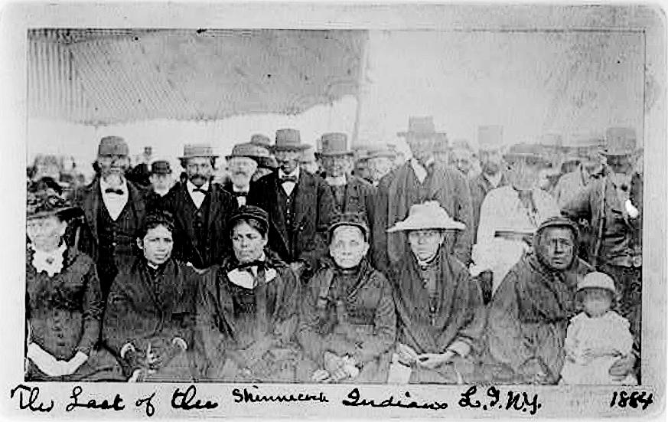

DIS-Last of the Shinnecock Indians, L.I., N.Y. 1884